Firewall Detection & IDS Evasion:
-sA flag in the nmap help us to identify the the firewall if it is present.
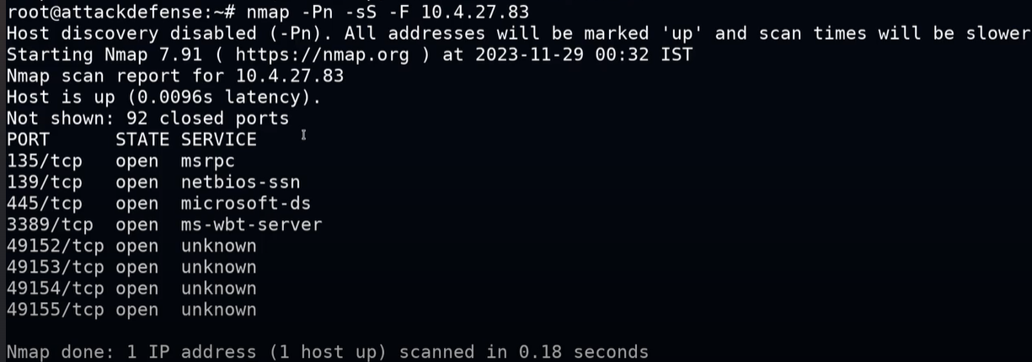
Instead of 92 closed ports there is the filtered port then there is firewall set.

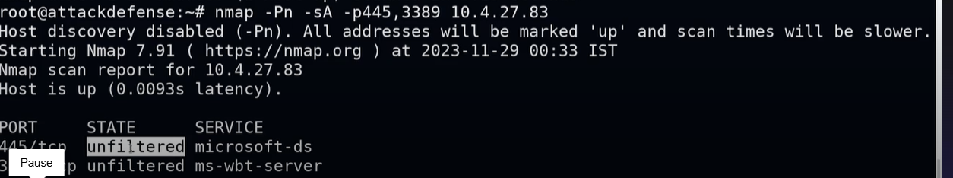

If there is a firewall then their comes the filtered state.

Firewall /IDS evasion:
-f = fragmentation (break the packet in to the small pieces)
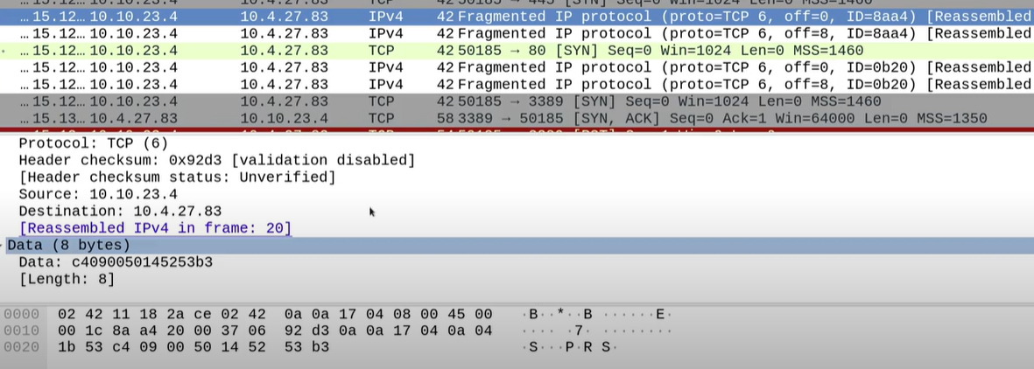
Mtu=maximum transmitted unit

Sppofing /decoy address:
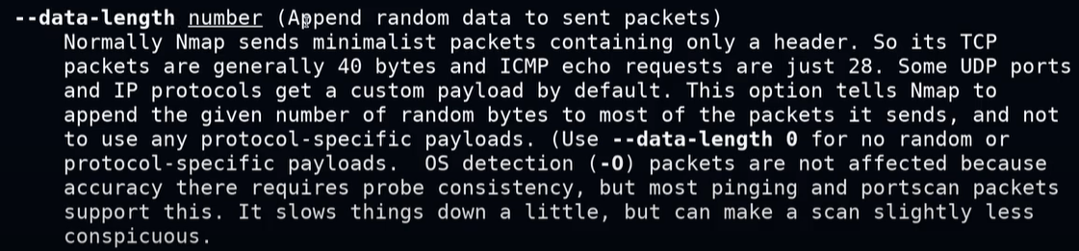

10.10.23.1 is the ip of the gateway.
And at the end enter the target ip-address.

Change the source ports by using -g

nmap --ttl 10 192.168.1.1
This sends packets with a TTL of 10, meaning they can pass through up to 10 routers.

nmap --data-length 50 192.168.1.1

This adds 50 bytes of random data to each probe.
It increases the packet size by adding junk data, which can help evade detection or analyze firewall behavior.

nmap -D 192.168.1.5,192.168.1.6,ME 192.168.1.10
• Sends fake packets from IPs 192.168.1.5 and 192.168.1.6.
• ME means your real IP is mixed in randomly.
• The target sees multiple attackers, not just you.

All of these are used to evade the firewall/ids throught some sort.

